**LAB 1 Admin1**

**2. What is the difference between cat and more command?**

**cat**

* **Purpose: Displays the entire content of a file.**
* **Behavior: Outputs all file content to the terminal at once.**
* **Use Case: Ideal for small files or when you need to concatenate and display multiple files**

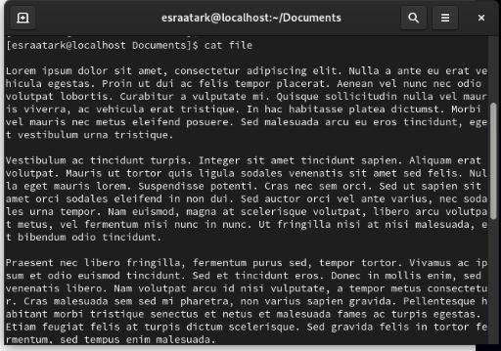

**more**

* **Purpose**: Allows viewing file content one screen at a time.
* **Behavior**: Displays content page by page, useful for larger files.
* **Use Case**: Better for reading large files interactively

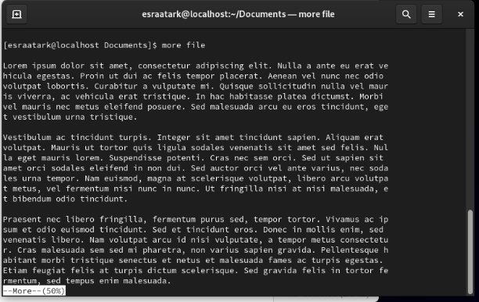

**3. What is the difference between rm and rmdir using man?**

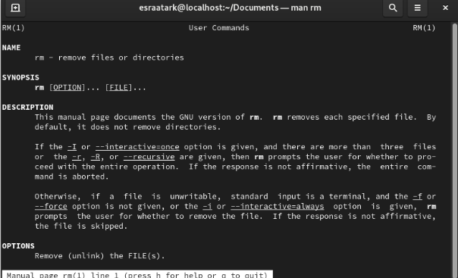

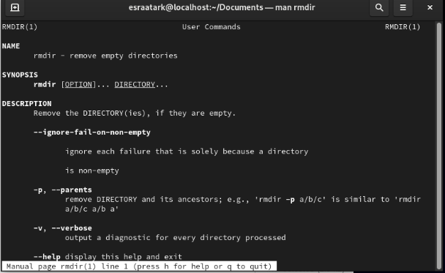

**4. Create the following hierarchy under your home directory?**

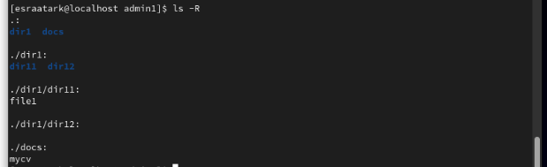

1. **Remove dir11 in one-step. What did you notice? And how did you overcome that?**





1. **Then remove dir12 using rmdir –p command. State what happened to the hierarchy (Note: you are in your home directory).**



The dir1 also removed.

1. **The output of the command pwd was /home/user. Write the absolute and relative path for the file mycv**

**Absolute: mycv is file here**



**Relative:mycv1 is directory here**



**5. Copy the /etc/passwd file to your home directory making its name is mypasswd?**



**6. Rename this new file to be oldpasswd?**



**7. You are in /user/bin, list four ways to go to your home directory**





**9. Display the first 4 lines of /etc/passwd**

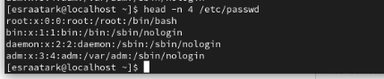

**10.Display the last 7 lines of /etc/passwd**

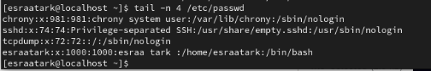

**11.Display the man pages of passwd the command and the file sequentially in one command.**



**11&12.Display the man page of the passwd file.**

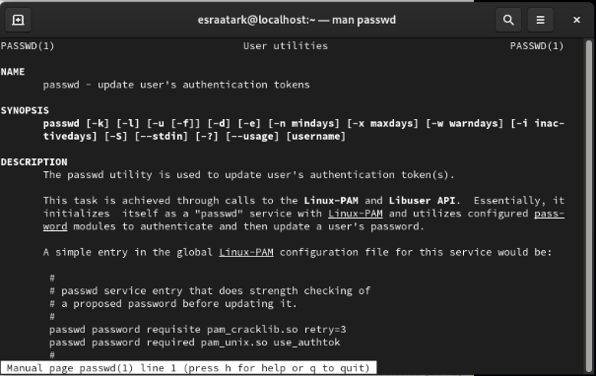

**11.**

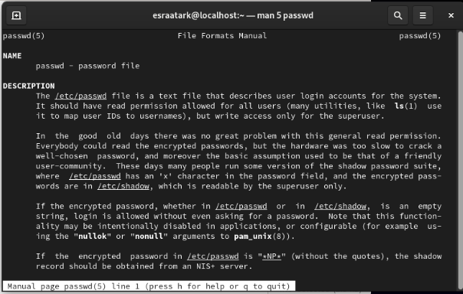

**13.Display a list of all the commands that contain the keyword passwd in their man page.**



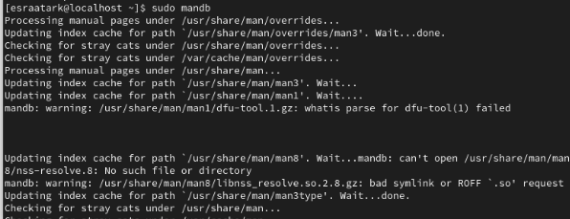

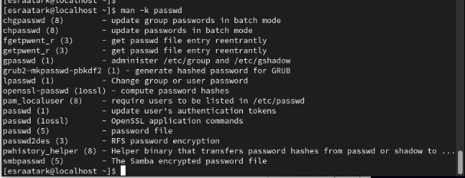

**Esraa tark mohammed foda**

**OS**

**Group2**